

**Green University of Bangladesh**

**Department of Computer Science and Engineering (CSE)**

**Faculty of Sciences and Engineering**

**Semester: (Fall, Year:2024, B.Sc. in CSE (Day)**

**Lab Report NO #08**

**Course Title: Mobile Application Development**

**Course Code: CSE-426 Section: 213 D-3**

**Lab Experiment Name: Show whenever battery percentage is changed.**

**Student Details**

|  |  |  |
| --- | --- | --- |
| **Name** | | **ID** |
| **1.** | Nadib Rana | 213002247 |

**Lab Date : 30.11.2024**

**Submission Date : 07.12.2024**

**Course Teacher’s Name** **: Md. Jahid Tanvir**

|  |
| --- |
| **Lab Report Status**  **Marks: ………………………………… Signature:.....................**  **Comments:.............................................. Date:..............................** |

**1.TITLE OF THE LAB REPORT EXPERIMENT**

Design a Broadcast Receiver which will show whenever battery percentage is changed

**2. OBJECTIVES**

* To understand the concept and usage of a BroadcastReceiver in Android.
* To dynamically register and handle system-wide broadcasts in Android applications.
* To retrieve and display battery percentage changes using the BatteryManager system service.

**3. PROCEDURE**

* Create a New Android Project:
  + Open Android Studio and start a new project.
* Design the Interface:
  + Add a `TextView` in the layout file (`activity_main.xml`) to display the battery percentage.
* 3.Create a BroadcastReceiver:
  + Create a new class that extends `BroadcastReceiver`.
  + In the `onReceive()` method, retrieve the battery level using the `BatteryManager`.
* Register the Receiver:
  + Declare the `BroadcastReceiver` in the `AndroidManifest.xml` file.
  + Use the `BATTERY_CHANGED` action in the `<intent-filter>`.
* Run and Test:
  + Install the app on a device.
  + Check that the battery percentage is displayed when the battery status changes.

**4. PROCEDURE**

**mainActivity.java**

package com.example.batterylistener;  
  
import android.content.Intent;  
import android.content.IntentFilter;  
import android.os.BatteryManager;  
import android.os.Bundle;  
import android.widget.TextView;  
  
import androidx.appcompat.app.AppCompatActivity;  
  
public class MainActivity extends AppCompatActivity {  
  
 private TextView batteryStatusText;  
  
 @Override  
 protected void onCreate(Bundle savedInstanceState) {  
 super.onCreate(savedInstanceState);  
 setContentView(R.layout.*activity_main*);  
  
 batteryStatusText = findViewById(R.id.*batteryStatusText*);  
  
 // Register BatteryChanged Intent dynamically  
 IntentFilter ifilter = new IntentFilter(Intent.*ACTION_BATTERY_CHANGED*);  
 Intent batteryStatus = registerReceiver(null, ifilter);  
  
 if (batteryStatus != null) {  
 // Extract battery level and scale  
 int level = batteryStatus.getIntExtra(BatteryManager.*EXTRA_LEVEL*, -1);  
 int scale = batteryStatus.getIntExtra(BatteryManager.*EXTRA_SCALE*, -1);  
  
 // Calculate battery percentage  
 float batteryPct = (level / (float) scale) * 100;  
  
 // Update UI  
 batteryStatusText.setText("Battery Level: " + (int) batteryPct + "%");  
 } else {  
 batteryStatusText.setText("Unable to get battery status.");  
 }  
 }  
}

**BatteryReceiver.java**

package com.example.batterylistener;  
  
import android.content.BroadcastReceiver;  
import android.content.Context;  
import android.content.Intent;  
import android.os.BatteryManager;  
import android.widget.Toast;  
import android.util.Log;  
  
public class BatteryReceiver extends BroadcastReceiver {  
  
 @Override  
 public void onReceive(Context context, Intent intent) {  
 // Get battery status  
 int level = intent.getIntExtra(BatteryManager.*EXTRA_LEVEL*, -1); // Current battery level  
 int scale = intent.getIntExtra(BatteryManager.*EXTRA_SCALE*, -1); // Max battery level  
  
 // Calculate the battery percentage  
 float batteryPercentage = (level / (float) scale) * 100;  
  
 // Log the battery percentage  
 Log.*d*("BatteryReceiver", "Battery Level: " + batteryPercentage + "%");  
  
 // Display the battery percentage in a Toast  
 Toast.*makeText*(context, "Battery Level: " + batteryPercentage + "%", Toast.*LENGTH_LONG*).show();  
 }  
}

**mainActivity.java**

<?xml version="1.0" encoding="utf-8"?>  
<LinearLayout xmlns:android="http://schemas.android.com/apk/res/android"  
 android:layout_width="match_parent"  
 android:layout_height="match_parent"  
 android:orientation="vertical"  
 android:padding="16dp">  
  
 <TextView  
 android:id="@+id/batteryStatusText"  
 android:layout_width="wrap_content"  
 android:layout_height="wrap_content"  
 android:text="Battery Level Will Show Here"  
 android:textSize="18sp"  
 android:layout_marginTop="50dp" />  
  
</LinearLayout>

**AndridManifest.xml**

<?xml version="1.0" encoding="utf-8"?>  
<manifest xmlns:android="http://schemas.android.com/apk/res/android">  
  
 <application  
 android:allowBackup="true"  
 android:label="@string/app_name"  
 android:roundIcon="@mipmap/ic_launcher_round"  
 android:supportsRtl="true"  
 android:theme="@style/Theme.BatteryListener">  
  
  
 <activity  
 android:name=".MainActivity"  
 android:exported="true">  
 <intent-filter>  
 <action android:name="android.intent.action.MAIN" />  
 <category android:name="android.intent.category.LAUNCHER" />  
 </intent-filter>  
 </activity>  
  
  
 <receiver  
 android:name=".BatteryReceiver"  
 android:exported="false">  
 <intent-filter>  
 <action android:name="android.intent.action.BATTERY_CHANGED" />  
 </intent-filter>  
 </receiver>  
  
 </application>  
  
</manifest>

**OUTPUT:**

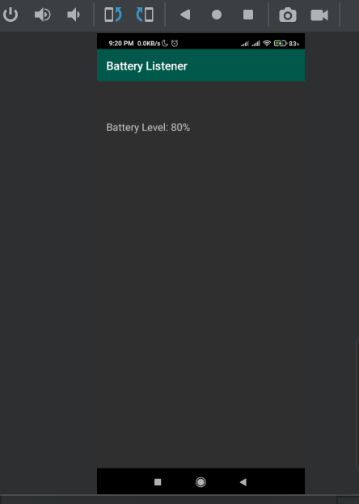

**Overview:**

